2FA: Two-Factor Authentication
- an extra layer of security
- Password + second verification = stronger security
for example:
username: ………..(most of the time, everyone knows what your username is)
password:…………..(it can be hacked through phishing, third party data breaches etc.)

Basically if anyone can login through this username and password to our account.
That is why we need Two-Factor Authentication .
If we have 2FA enabled in our apps or websites, then even when somebody tries to enter into our account, they will need to further verify through either OTP or emails or biometrics, etc. and if they cannot verify they won’t be able to access the account. This is the Two-Factor Authentication or Two-Step verification.

In General there are three factors in 2FA:
- Knowledge factor:
meaning something you know ( like passwords, pins or patterns)
- Possession factor:
its something that you possess physically or digitally (mobile applications, hardware keys, or SMS codes)
- Inherence factor:
Something you are (biometrics like facial recognition, fingerprint, iris scan etc.)

Evidence of research:
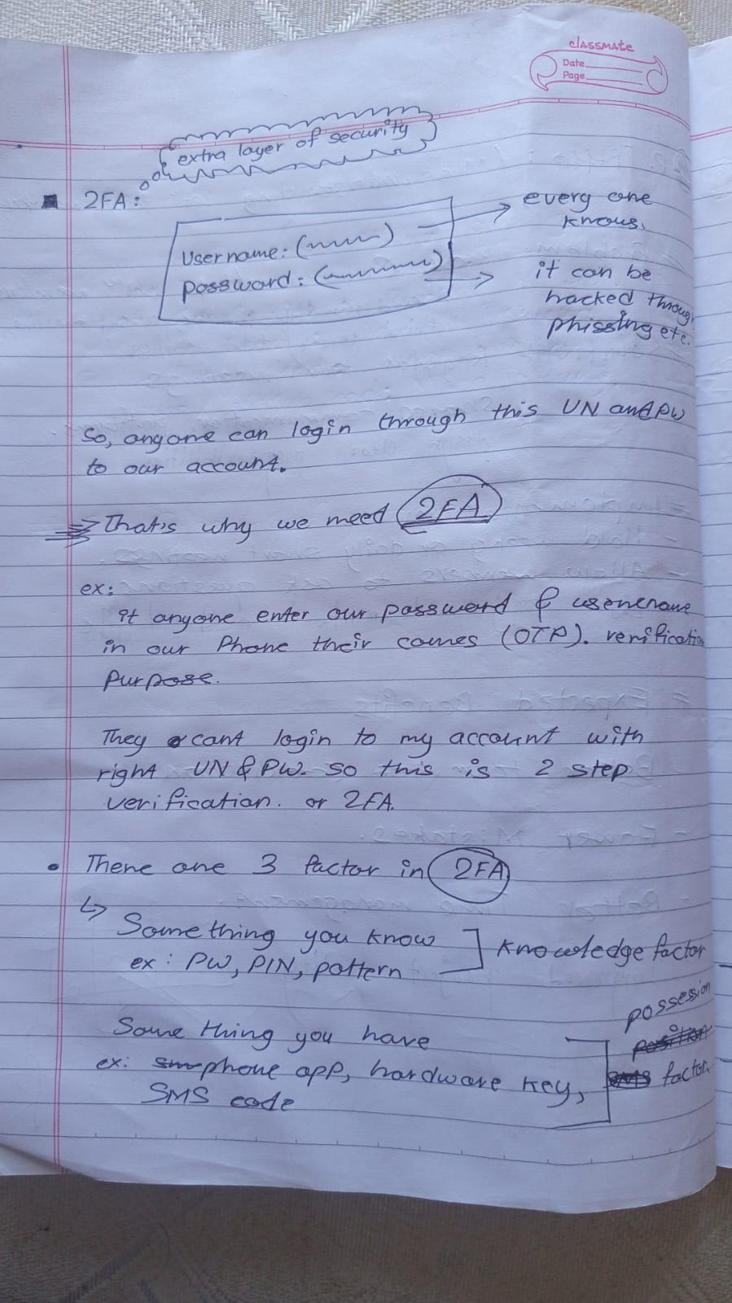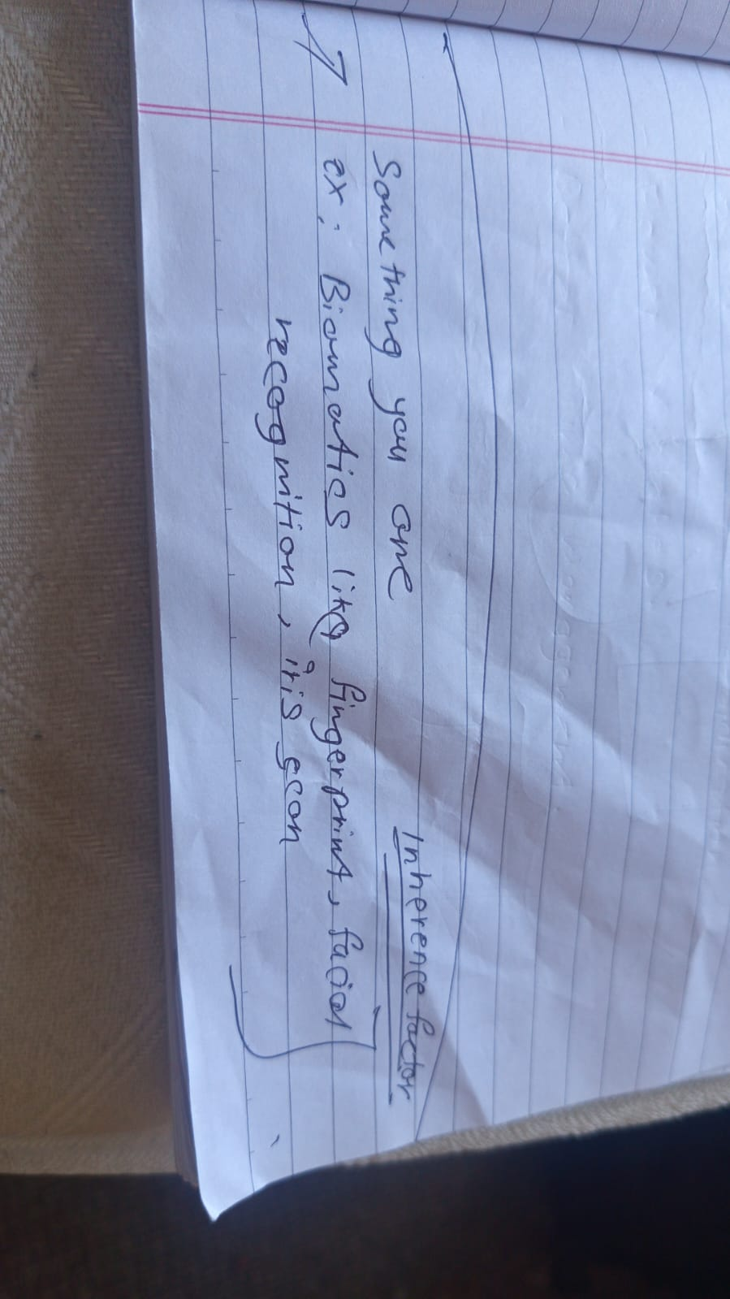
2FA methods, its weaknesses and uses:
2FA method | How it works | Weaknesses | Real-life use
SMS OTP | Code send by text message | SIM swap scams, weak signals | Instagram, banking apps
Authenticator apps | App generates login code | Phone loss can lock users out | Gmail, discord, GitHub
Email verification | Code link send to email | Unsafe if email is hacked | Password resets, logins
Push notifications | User approves login | MFA fatigue spam attacks | Microsoft, banking apps
biometrics | Fingerprint or face ID login | Sensor errors, privacy concerns | Smartphones, banking apps

Research shows, some MFA(multi-factor Authentication) are stronger than others, especially against phishing attacks.

Human Error in Cybersecurity:
OneCollab (n.d.) states that Human error remains to be the root cause of 74% to 95% of all date breaches. Verizon’s 2023 report highlights that 74% of all breaches involved a human element, revealing the vulnerabilities linked to lapses in judgment or oversight.
Similarly According to an IBM report, the cost of a single enterprise data breach soared to $4.5 million between March 2022 and March 2023. Organisations not using AI and Automation faced even higher costs, with breaches averaging $5.4 million.
Likewise 67% of data breaches were discovered by external third parties or when attackers voluntarily disclosed their actions, indicating serious gaps in internal oversight
